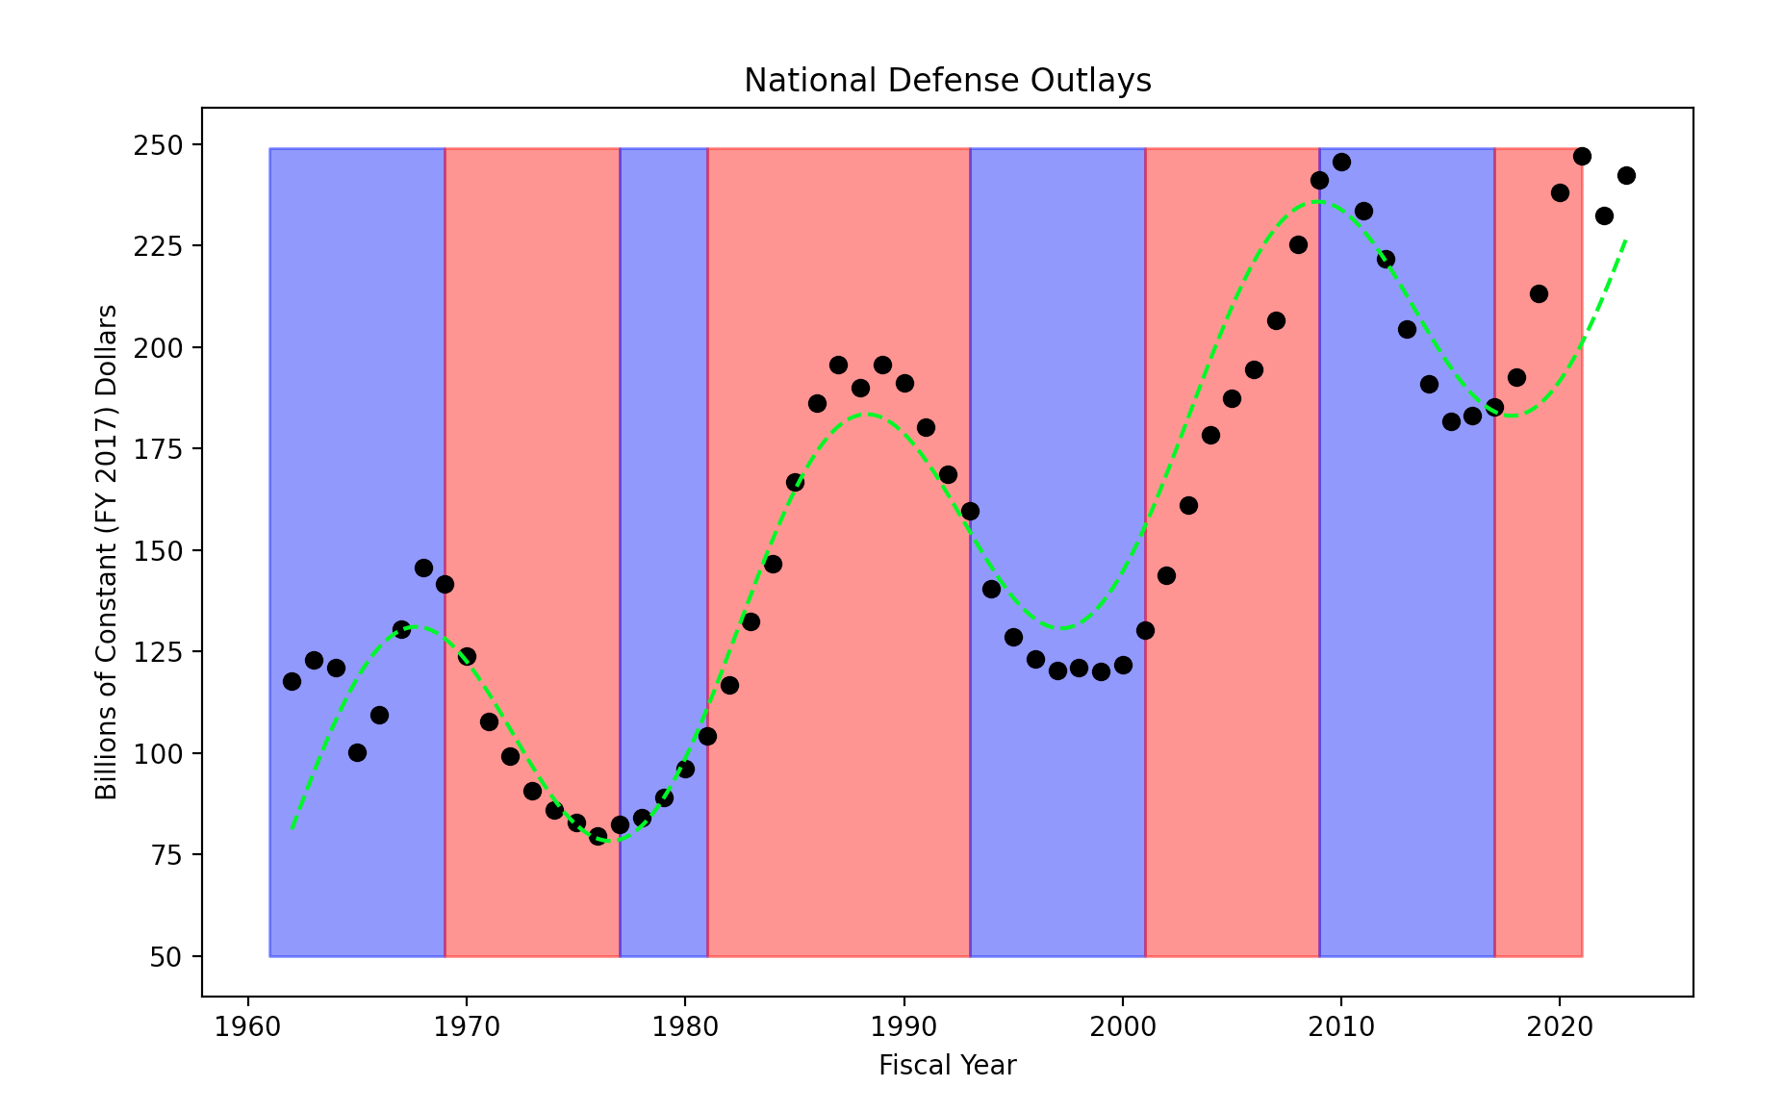

Democrats Hold Pres Office

Republicans Hold Pres Office

* Observation: Perfect cyclic trend happening every 20 years in national defense outlays.
* Analysis: No correlation between presidential political party and the upward or downward trend of outlay cycles.
* Conclusion: Changing of the political parties of the office of the president is not what influences the cyclic trend of national defense outlays.